Group_descrip_lin2.R

daitu

Tue Jun 21 23:16:48 2016

## 2016年暑期课程设计  
## 问题：Grupo Bimbo Inventory Demand  
## 宾堡集团的库存需求  
## 最大限度地提高销售和最大限度地减少烘焙食品的退回  
## Daitu  
## start:2016.06.21  
## 参考借鉴kaggle上的公开程序  
  
  
setwd("/Users/Daitu/数据分析/kaggle/Grupo Bimbo")  
getwd()

## [1] "/Users/daitu/数据分析/kaggle/Grupo Bimbo"

## 加载包  
  
library(data.table)  
library(ggplot2)

## Warning: package 'ggplot2' was built under R version 3.2.4

library(dplyr)

##   
## Attaching package: 'dplyr'

## The following objects are masked from 'package:data.table':  
##   
## between, last

## The following objects are masked from 'package:stats':  
##   
## filter, lag

## The following objects are masked from 'package:base':  
##   
## intersect, setdiff, setequal, union

library(treemap)

## Warning: package 'treemap' was built under R version 3.2.4

## 读取数据####  
## 1:读取训练集  
system.time({  
 traindata <- fread("train.csv",sep=",",header = TRUE)  
})

##   
Read 0.0% of 74180464 rows  
Read 4.4% of 74180464 rows  
Read 8.6% of 74180464 rows  
Read 12.9% of 74180464 rows  
Read 17.2% of 74180464 rows  
Read 21.6% of 74180464 rows  
Read 25.9% of 74180464 rows  
Read 30.2% of 74180464 rows  
Read 34.6% of 74180464 rows  
Read 38.9% of 74180464 rows  
Read 43.2% of 74180464 rows  
Read 47.5% of 74180464 rows  
Read 51.7% of 74180464 rows  
Read 56.0% of 74180464 rows  
Read 60.3% of 74180464 rows  
Read 64.6% of 74180464 rows  
Read 68.9% of 74180464 rows  
Read 73.2% of 74180464 rows  
Read 77.5% of 74180464 rows  
Read 81.9% of 74180464 rows  
Read 86.2% of 74180464 rows  
Read 90.5% of 74180464 rows  
Read 94.8% of 74180464 rows  
Read 99.1% of 74180464 rows  
Read 74180464 rows and 11 (of 11) columns from 2.980 GB file in 00:00:30

## user system elapsed   
## 26.827 2.294 29.126

# Read 74180464 rows and 11 (of 11) columns from 2.980 GB file in 00:00:29  
# 用户 系统 流逝   
# 26.553 2.077 28.869  
  
## 2:读取客户名单数据  
cliente_tabla <- fread("cliente_tabla.csv",sep=",",header = TRUE)  
  
## 3:读取产品名单数据  
producto_tabla <- fread("producto_tabla.csv",sep=",",header = TRUE)  
  
## 4:读取城镇和国家（州）数据  
town_state <- fread("town_state.csv",sep=",",header = TRUE)

## 数据的描述统计####

## 1:分析数据的周数：Semana  
Semana <- data.frame(table(traindata$Semana))  
colnames(Semana) <- c("Semana","Freq")  
# 3 4 5 6 7 8 9   
# 11165207 11009593 10615397 10191837 10382849 10406868 10408713   
## 条形图  
ggplot(data = Semana,aes(Semana,Freq)) +   
 geom_bar(stat = "identity", width = 0.6,fill = "lightblue",colour = "black") +   
 theme_grey(base_family = "STKaiti") +  
 scale_y_continuous() +   
 labs(x="周数",y="数据条数",title = "每周数据的记录数")

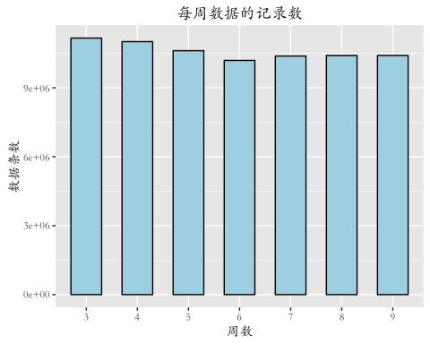

## 销售站的数据分析#####  
## 2 ：销售站Agencia 和 州State  
agencias <- traindata %>%  
 group_by(Agencia_ID) %>% # 数据按照销售战进行分组统计  
 summarise(Units = sum(Venta_uni_hoy), # 总结多个值为一个值，units：本销售站的销量和  
 Pesos = sum(Venta_hoy), # 本周的销售量（比索）之和  
 Return_Units = sum(Dev_uni_proxima), # 下星期的返回量之和  
 Return_Pesos = sum(Dev_proxima), # 下星期的返回量（比索）之和  
 Net = sum(Demanda_uni_equil)) %>% # 调整后的需求和  
 mutate(Net_Pesos = Pesos - Return_Pesos, # mutate:添加新的变量   
 Return_Rate = Return_Units / (Units+Return_Units)) %>% # 添加变量退货比率  
 arrange(desc(Units)) %>% # 将数据按照变量Units的降序排列  
 inner_join(town_state, by="Agencia_ID") # 按照变量Agencia_ID，连接两个表，return all rows from x   
  
## 可视化x：每天销量，y：销售站的数量  
ggplot(agencias, aes(x=Units/7))+  
 geom_histogram(fill="red", color="gray", binwidth=10000)+ #条形图的宽度为10000  
 theme_bw(base_family = "STKaiti") +   
 scale_x_continuous(labels=function(x)paste(x/1000, "k"))+  
 labs(x = "每天的平均销量",y = "销售站数量",title = "销售站的销量")

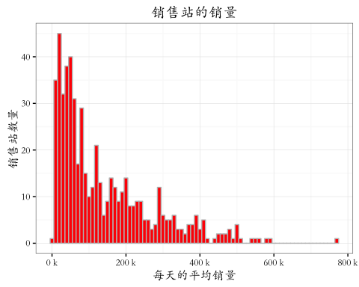

## 前100的销售站的销量树图  
treemap(agencias[1:100, ],   
 index=c("Agencia_ID"), vSize="Units", vColor="Return_Rate",   
 type="value", title.legend="Units return %", title="Top 100 agencias")

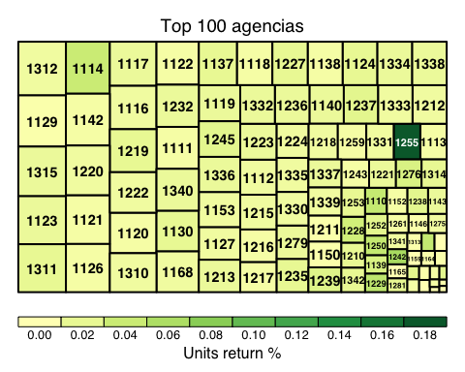

## 销售站的历史数据分析  
agencias_history <- traindata %>%  
 group_by(Agencia_ID, Semana) %>% # 数据按照销售站、星期数，进行分组统计  
 summarise(Units = sum(Venta_uni_hoy), # 总结多个值为一个值，units：销量和  
 Pesos = sum(Venta_hoy),  
 Return_Units = sum(Dev_uni_proxima),  
 Return_Pesos = sum(Dev_proxima),  
 Net = sum(Demanda_uni_equil)) %>%  
 mutate(Net_Pesos = Pesos - Return_Pesos,  
 Avg_Pesos = Pesos / Units,  
 Return_Rate = Return_Units / (Units+Return_Units)) %>%  
 arrange(Agencia_ID, Semana) %>% # 将数据按照变量 销售站、星期数的降序排列  
 inner_join(town_state, by="Agencia_ID")  
## 取出销售量前30的销售站ID  
top30agencias <- agencias$Agencia_ID[1:30]  
  
## 销量前30的销售站���每周的销量和退货率图  
ggplot(agencias_history %>% filter(Agencia_ID %in% top30agencias))+  
 geom_bar(aes(x=Semana, y=Units, fill=Return_Rate), stat="identity", color="black")+  
 theme_bw(base_family = "STKaiti") +  
 facet_wrap(~Agencia_ID)+ # 按照销售站划分成子图  
 scale_y_continuous(labels=function(x)paste(x/1000, "k"))+  
 scale_fill_gradient(name="退回\n百分比", low="white", high="red")+  
 ggtitle("销量前30的销售站") + ylab("销量") +xlab("星期")

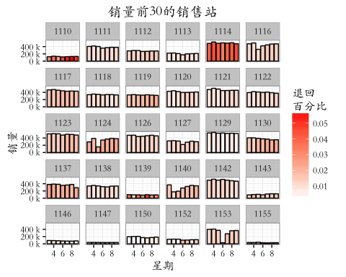

## 每个州的销售数据的分析  
states <- agencias_history %>%  
 group_by(State, Semana) %>% #数据按照州和星期分组  
 summarise(Units = sum(Units),  
 Pesos = sum(Pesos),  
 Return_Units = sum(Return_Units),  
 Return_Pesos = sum(Return_Pesos),  
 Net = sum(Net)) %>%  
 mutate(Avg_Pesos = Pesos / Units,  
 Return_Rate = Return_Units / (Units+Return_Units)) %>%  
 arrange(desc(Units)) # 数据按照销量排列  
  
## 地点－－星期 －－退回百分比 图像可视化  
ggplot(states)+  
 geom_bar(aes(x=Semana, y=Units, fill=Return_Rate), stat="identity", color="black")+  
 theme_bw(base_family = "STKaiti") +  
 facet_wrap(~State)+  
 scale_y_continuous(labels=function(x)paste(x/1e6, "m"))+  
 scale_fill_gradient(name="退回\n百分比", low="white", high="red")+  
 ggtitle("州的销售量")+ ylab("销量") +xlab("星期")

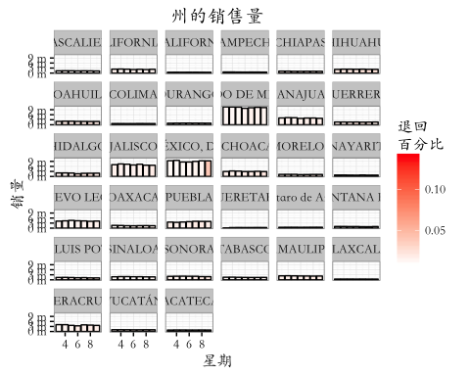

## 销售渠道的分析####  
  
canals <- traindata %>%  
 group_by(Canal_ID, Semana) %>% #根据销售渠道和星期进行分组  
 summarise(Units = sum(Venta_uni_hoy),  
 Pesos = sum(Venta_hoy),  
 Return_Units = sum(Dev_uni_proxima),  
 Return_Pesos = sum(Dev_proxima),  
 Net = sum(Demanda_uni_equil)) %>%  
 mutate(Net_Pesos = Pesos - Return_Pesos,  
 Avg_Pesos = Pesos / Units,  
 Return_Rate = Return_Units / (Units+Return_Units)) %>%  
 arrange(desc(Units))  
# 销售渠道1占据主要的销量  
treemap(canals, index=c("Canal_ID"), vSize="Units", type="index",   
 title="Canals repartition")

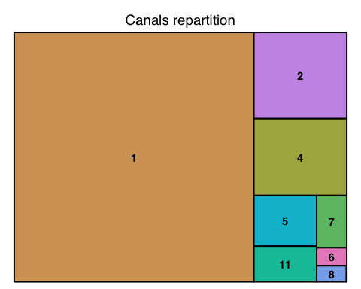

## 销售渠道的销量和星期和退货率  
ggplot(canals)+  
 geom_bar(aes(x=Semana, y=Units, fill=Return_Rate), stat="identity", color="black")+  
 theme_bw(base_family = "STKaiti") +  
 facet_wrap(~Canal_ID, scale="free")+  
 scale_y_continuous(labels=function(x)paste(x/1e6, "m"))+  
 scale_fill_gradient(name="退回\n百分比", low="white", high="red")+  
 ggtitle("销售渠道")+ ylab("销量") +xlab("星期")

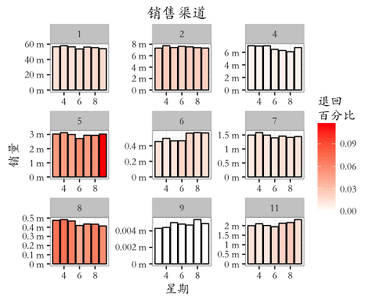

## 销售渠道和销售站分析####  
agencias_canals <- traindata %>%  
 group_by(Agencia_ID) %>%  
 summarise(n_canals = n_distinct(Canal_ID)) #添加该销售渠道有多少销售站  
  
## 销售渠道有多少销售站可视化  
ggplot(agencias_canals)+  
 geom_histogram(aes(x=n_canals), fill="red", color="black", alpha="0.5", binwidth=0.5)+  
 theme_bw(base_family = "STKaiti") +  
 scale_x_continuous(breaks=1:5)+  
 scale_y_continuous()+  
 theme(axis.text.x=element_text(hjust=1)) +  
 labs(x = "销售渠道数量",y = "销售站数量",title = "销售站的销售渠道量")

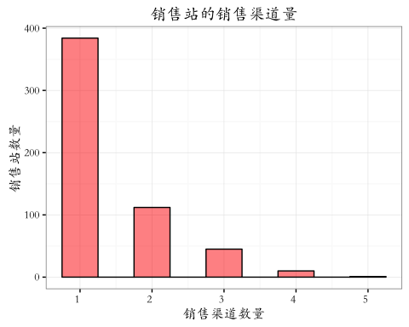

# 大部分销售站有1条销售渠道，只有很少的销售站有超过三条的销售渠道  
  
## 销售路线的分析####  
routes <- traindata %>% group_by(Ruta_SAK) %>%  
 summarise(n_Agencias = n_distinct(Agencia_ID), #销售路线有多少销售站  
 n_Clients = n_distinct(Cliente_ID), #销售路线有多少客户  
 Units=sum(Venta_uni_hoy), #销售路线的销售量  
 Return_Units = sum(Dev_uni_proxima)) %>% #销售路线的销售量退货量  
 mutate(Return_Rate = Return_Units / (Units+Return_Units)) %>% # 添加退货率变量  
 arrange(desc(Units)) # 按照销量排序  
  
ggplot(routes, aes(x=Units/7))+  
 geom_histogram(fill="red", color="gray", binwidth=5000)+  
 theme_bw(base_family = "STKaiti") +  
 scale_x_continuous(labels=function(x)paste(x/1000, "k"))+  
 scale_y_continuous()+  
 labs(x = "平均每天销量",y = "销售路线数量")

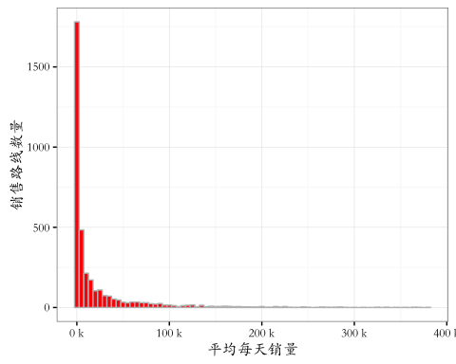

## 大部分的销售路线的销售量并不多，超过2/3的销售路线每天的销售量不超过10千  
  
  
## 销售路线和销售站#####  
routes_agencias <- traindata %>% group_by(Ruta_SAK, Agencia_ID) %>%  
 summarise(count=n(), #当前分组的观测数  
 n_Clients = n_distinct(Cliente_ID), # 客户数量  
 Units=sum(Venta_uni_hoy), #销售量求和  
 Return_Units = sum(Dev_uni_proxima)) %>%  
 mutate(Return_Rate = Return_Units / (Units+Return_Units)) %>%  
 arrange(desc(Units))  
top100routes <- routes$Ruta_SAK[1:100] # 销量前100的路线  
top100agencias <- agencias$Agencia_ID[1:100] # 销量前100的销售站  
## 可视化  
ggplot(routes_agencias %>%   
 filter(Ruta_SAK %in% top100routes, Agencia_ID %in% top100agencias))+  
 geom_point(aes(x=as.character(Ruta_SAK),   
 y=as.character(Agencia_ID),   
 size=Units, color=Return_Rate))+  
 theme_bw(base_family = "STKaiti") +  
 scale_color_gradient(name="退回\n百分比", low="blue", high="red")+  
 scale_size_continuous(name = "销量",range = c(1,4)) +  
 theme(axis.line=element_blank(),  
 axis.text.x=element_blank(),  
 axis.text.y=element_blank()) +  
 labs(x = "销售路线",y = "销售站",title = "销量前100的销售站&销售路线")

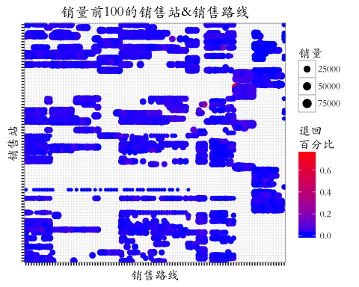

top50routes <- routes$Ruta_SAK[1:50] # 销量前100的路线  
top50agencias <- agencias$Agencia_ID[1:50] # 销量前100的销售站  
## 可视化  
ggplot(routes_agencias %>%   
 filter(Ruta_SAK %in% top50routes, Agencia_ID %in% top50agencias))+  
 geom_point(aes(x=as.character(Ruta_SAK),   
 y=as.character(Agencia_ID),   
 size=Units, color=Return_Rate))+  
 theme_bw(base_family = "STKaiti") +  
 scale_color_gradient(name="退回\n百分比", low="blue", high="red")+  
 scale_size_continuous(name = "销量",range = c(1,6)) +  
 theme(axis.line=element_blank(),  
 axis.text.x=element_blank(),  
 axis.text.y=element_blank()) +  
 labs(x = "销售路线",y = "销售站",title = "销量前50的销售站&销售路线")

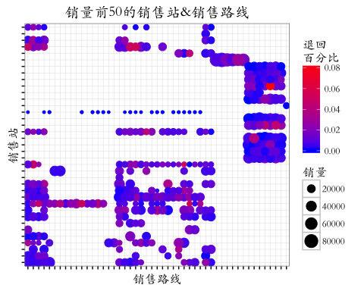

## 对客户数据进行分析#####  
sales <- traindata %>% #客户数据  
 group_by(Cliente_ID) %>% # 按照客户id分组  
 summarise(Units = sum(Venta_uni_hoy),   
 Pesos = sum(Venta_hoy), # 本周销售金额  
 Return_Units = sum(Dev_uni_proxima),  
 Return_Pesos = sum(Dev_proxima), # 下星期的退回金额  
 Net = sum(Demanda_uni_equil)) %>%  
 mutate(Return_Rate = Return_Units / (Units+Return_Units),  
 Avg_Pesos = Pesos / Units) %>% # 单价  
 mutate(Net_Pesos = Pesos - Return_Pesos) %>% # 实际销售金额  
 inner_join(cliente_tabla, by="Cliente_ID") %>%  
 arrange(desc(Pesos)) # 本周销售金额排序  
# 花费量前100个客户的树形图  
# 可见有一个大客户：Puebla Remision  
treemap(sales[1:100, ],   
 index=c("NombreCliente"), vSize="Units", vColor="Return_Rate",   
 palette=c("#FFFFFF","#FFFFFF","#FF0000"),  
 type="value", title.legend="Units return %", title="Top 100 clients")

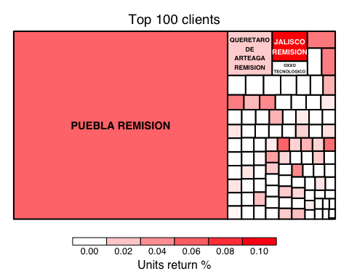

## 客户的累积消耗量  
sales$Cum_Units <- cumsum(sales$Units) / sum(sales$Units) # 累积百分比  
s <- seq(1, 800000, 100) # 约有80万个客户  
ggplot()+geom_line(aes(x=s, y=sales$Cum_Units[s]))+  
 theme_bw(base_family = "STKaiti") +  
 scale_x_continuous(labels=function(x) paste(x/1000, "k"))+  
 ggtitle("客户分配")+ xlab("客户数量")+ylab("累积百分比(销量)")

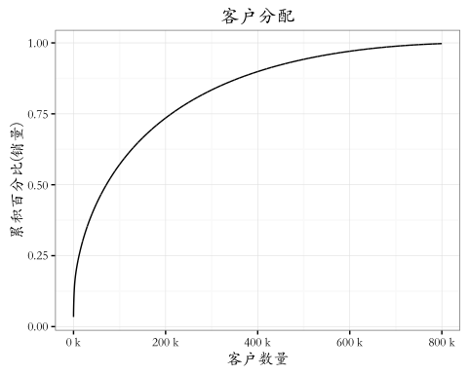

## 前20万客户约贡献了75％的销售量  
  
  
  
## 客户和销售站分析####  
agencias_by_client <- traindata %>%  
 group_by(Cliente_ID) %>% #按照客户id分组  
 summarise(n_agencias = n_distinct(Agencia_ID)) %>% #多少个销售站  
 inner_join(cliente_tabla, by="Cliente_ID")   
  
table(agencias_by_client$n_agencias)

##   
## 1 2 3 4 5 9 62   
## 844113 37510 3771 19 1 1 1

# 1 2 3 4 5 9 62   
# 844113 37510 3771 19 1 1 1   
# 大部分的客户只从一个销售站购买，只有几个客户购买狗的销售站 >= 5  
  
agencias_by_client %>% filter(n_agencias %in% c(5, 9, 62)) #返回符合条件的行

## Source: local data table [3 x 3]  
##   
## Cliente_ID n_agencias NombreCliente  
## (int) (int) (chr)  
## 1 188391 9 DESAYUNOS ESCOLARES  
## 2 653378 62 PUEBLA REMISION  
## 3 1274327 5 COMERCIALIZADORA LA PUERTA DEL SOL

# Cliente_ID n_agencias NombreCliente  
# (int) (int) (chr)  
# 1 188391 9 DESAYUNOS ESCOLARES  
# 2 653378 62 PUEBLA REMISION  
# 3 1274327 5 COMERCIALIZADORA LA PUERTA DEL SOL  
  
## 客户和购买渠道分析#####  
clients_canals <- traindata %>%  
group_by(Cliente_ID) %>%  
 summarise(n_canals = n_distinct(Canal_ID))  
  
## 大多数客户只有一个购买渠道。不同的销售渠道可以为一个客户提供服务。  
table(clients_canals$n_canals)

##   
## 1 2 3 4   
## 874022 6516 65 1

# 1 2 3 4   
# 874022 6516 65 1   
  
# 很少有销售站有同一个客户通过多个渠道。  
clients_agencies_canals <- traindata %>%  
 group_by(Cliente_ID, Agencia_ID) %>%  
 summarise(n_canals = n_distinct(Canal_ID))  
  
table(clients_agencies_canals$n_canals)

##   
## 1 2 3   
## 922108 3271 3

## 客户和路线分析#####  
clients_routes <- traindata %>%  
 group_by(Cliente_ID) %>%  
 summarise(n_routes = n_distinct(Ruta_SAK))  
  
## 大多数客户只有不到5个仓库的交货，但超过240个客户的工作与10个仓库或更多。  
sum(clients_routes$n_routes >= 10)

## [1] 242

ggplot(clients_routes)+  
 geom_histogram(aes(x=n_routes), fill="red", color="black", alpha="0.5", binwidth=1)+  
 theme_bw(base_family = "STKaiti") +  
 scale_y_continuous(labels=function(x) paste(x/1000, "k"))+  
 ggtitle("客户和销售路线")+ xlab("路线数量")+ylab("客户数量")

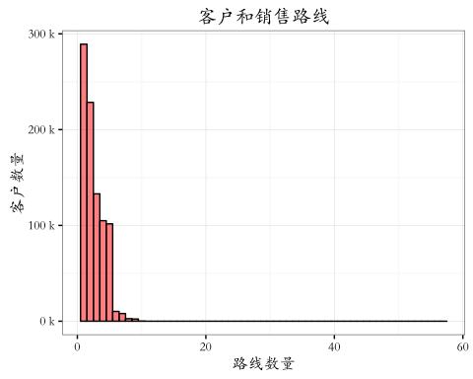

## 对集团销售的产品进行分析#####  
  
products <- traindata %>% group_by(Producto_ID) %>% #根据生产的产品进行分组  
 summarise(Units = sum(Venta_uni_hoy), # 销量  
 Pesos = sum(Venta_hoy), # 卖出的总钱数  
 Return_Units = sum(Dev_uni_proxima), # 被退回的总量  
 Return_Pesos = sum(Dev_proxima), #备退回的总钱数  
 Net = sum(Demanda_uni_equil)) %>% #调整后的我总需求  
 mutate(Avg_Pesos = Pesos / Units, # 每种产品的单价  
 Return_Rate = Return_Units / (Units+Return_Units)) %>% # 退货率  
 filter(!is.nan(Avg_Pesos)) %>% #剔除没有单价的商品  
 inner_join(producto_tabla, by="Producto_ID") %>%  
 arrange(desc(Units))  
  
products$NombreProducto <- factor(as.character(products$NombreProducto), levels=products$NombreProducto)  
  
# 销量前100的产品树图  
treemap(products[1:100, ],   
 index=c("NombreProducto"), vSize="Units", vColor="Return_Rate",   
 palette=c("#FFFFFF","#FFFFFF","#FF0000"),  
 type="value", title.legend="Units return %", title="Top 100 products")

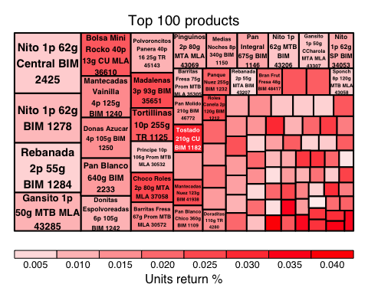

## 产品的家的密度分布  
ggplot(products, aes(x=Avg_Pesos))+  
 geom_histogram(aes(y=..density..), fill="gray", color="black", alpha="0.8")+  
 geom_density(fill="red", alpha="0.3")+  
 theme_bw(base_family = "STKaiti") +  
 scale_x_continuous(lim=c(0, 50))+  
 ggtitle("产品单价的分布")+ xlab("平均单价")+ylab("密度")

## `stat_bin()` using `bins = 30`. Pick better value with `binwidth`.

## Warning: Removed 74 rows containing non-finite values (stat_bin).

## Warning: Removed 74 rows containing non-finite values (stat_density).

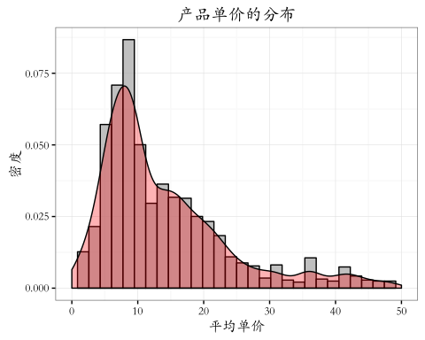

## 产品和销售站  
products_agencies <- traindata %>% group_by(Agencia_ID) %>%  
 summarise(n_products = n_distinct(Producto_ID))  
  
## 大多数销售站会卖100～200种产品  
ggplot(products_agencies)+  
 geom_histogram(aes(x = n_products), fill="red", color="black", alpha="0.5", binwidth=10)+  
 theme_bw(base_family = "STKaiti") +  
 ggtitle("销售站出售的产品数量")+ xlab("产品数量(种)")+ylab("销售站数量(个)")

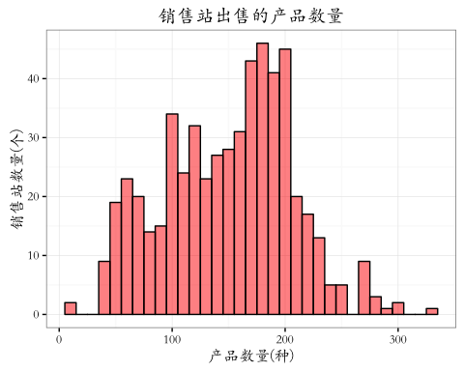

## 产品和销售路线  
routes_products <- traindata %>% group_by(Producto_ID) %>%  
 summarise(n_routes = n_distinct(Ruta_SAK))  
## 大部分的产品只有几条销售路线，只有几种产品的销售路线很多  
ggplot(routes_products)+  
 geom_histogram(aes(x=n_routes), fill="red", color="black", alpha="0.5", binwidth=10)+  
 theme_bw(base_family = "STKaiti") +  
 ggtitle("产品和销售线路")+ xlab("销售线路(条)")+ylab("产品数量(种)")

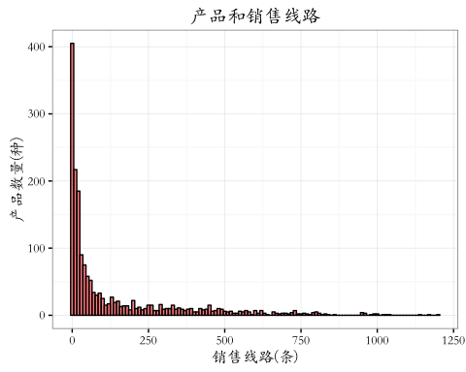

## 产品和销售路线 top100  
routes.products <- traindata %>% group_by(Ruta_SAK, Producto_ID) %>%  
 summarise(count=n(),  
 n_Agencias = n_distinct(Agencia_ID),  
 n_Clients = n_distinct(Cliente_ID),  
 Units=sum(Venta_uni_hoy),  
 Return_Units = sum(Dev_uni_proxima)) %>%  
 mutate(Return_Rate = Return_Units / (Units+Return_Units)) %>%  
 arrange(desc(Units))  
  
  
top100routes <- routes$Ruta_SAK[1:100]  
top100products <- products$Producto_ID[1:100]  
  
ggplot(routes.products %>%   
 filter(Ruta_SAK %in% top100routes, Producto_ID %in% top100products))+  
 geom_point(aes(x=as.character(Ruta_SAK),   
 y=as.character(Producto_ID),   
 size=Units, color=Return_Rate))+  
 theme_bw(base_family = "STKaiti")+  
 scale_color_gradient(name="退回\n百分比", low="blue", high="red")+  
 scale_size_continuous(name = "销量",range = c(1,6)) +  
 theme(axis.line=element_blank(),  
 axis.text.x=element_blank(),  
 axis.text.y=element_blank()) +  
 ggtitle("销量前100产品&线路")+ xlab("销售线路ID")+ylab("产品ID")

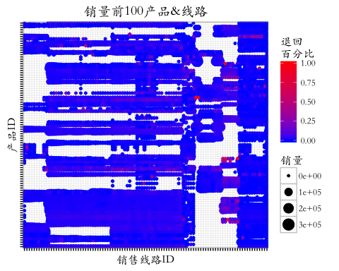

## 产品和销售路线 top50  
top50routes <- routes$Ruta_SAK[1:50]  
top50products <- products$Producto_ID[1:50]  
  
ggplot(routes.products %>%   
 filter(Ruta_SAK %in% top50routes, Producto_ID %in% top50products))+  
 geom_point(aes(x=as.character(Ruta_SAK),   
 y=as.character(Producto_ID),   
 size=Units, color=Return_Rate))+  
 theme_bw(base_family = "STKaiti")+  
 scale_color_gradient(name="退回\n百分比", low="blue", high="red")+  
 scale_size_continuous(name = "销量",range = c(1,8)) +  
 theme(axis.line=element_blank(),  
 axis.text.x=element_blank(),  
 axis.text.y=element_blank()) +  
 ggtitle("销量前50产品&线路")+ xlab("销售线路ID")+ylab("产品ID")

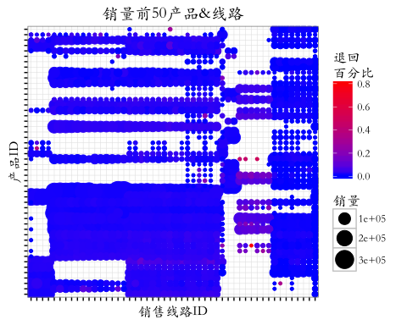

## 产品和客户  
products_by_client <- traindata %>%  
group_by(Cliente_ID) %>%  
 summarise(n_products = n_distinct(Producto_ID)) %>%  
 inner_join(cliente_tabla, by="Cliente_ID")  
  
ggplot(products_by_client)+  
 geom_histogram(aes(x=n_products), fill="red", color="black", alpha="0.3", binwidth=2)+  
 theme_bw(base_family = "STKaiti")+  
 scale_y_continuous(labels=function(x)paste(x/1000, "k"))+  
 ggtitle("产品量所对应的客户量")+ xlab("产品数量(种)")+ylab("客户数量(位)")

